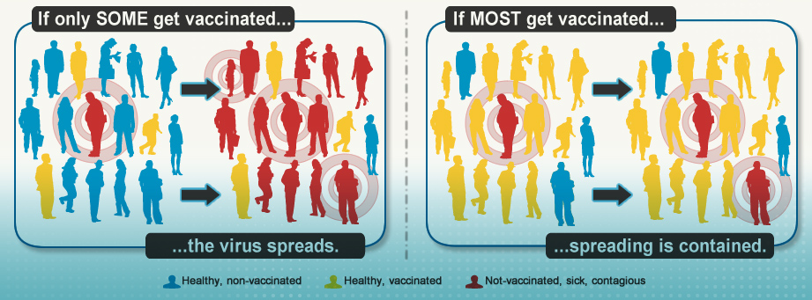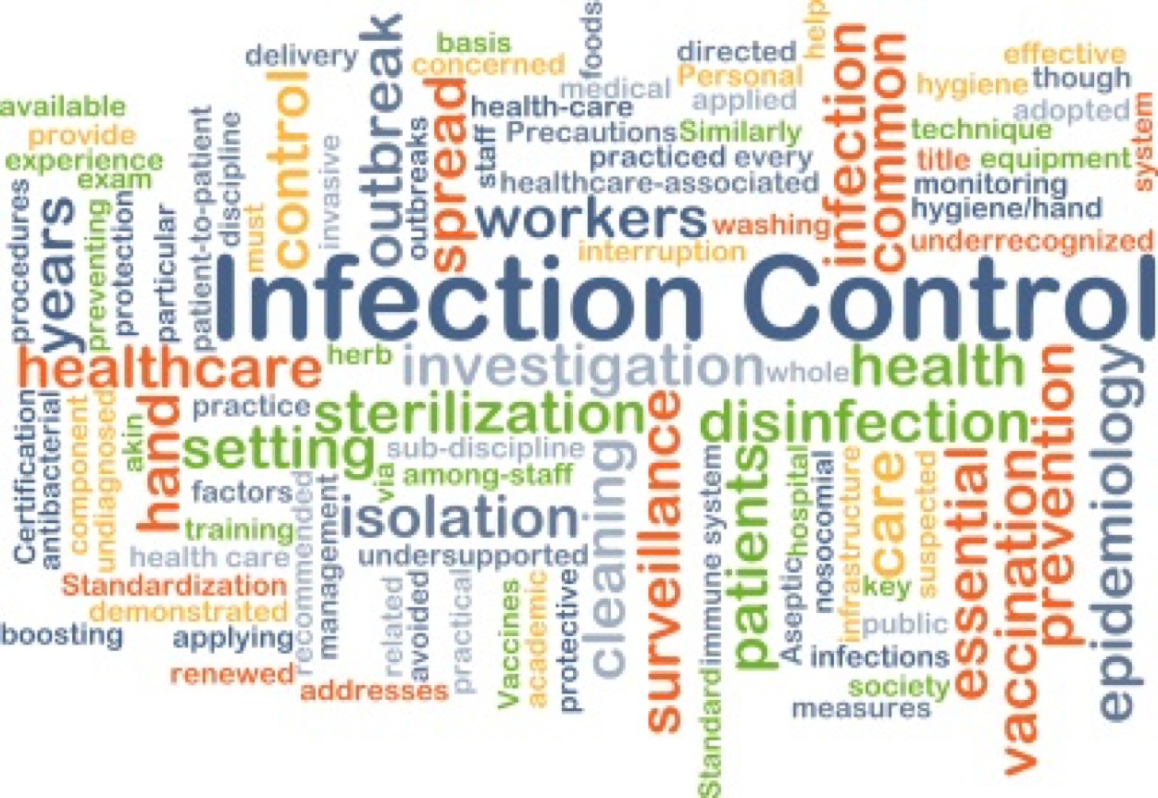

**INFECTION CONTROL**

**VACCINES, VACCINATION, AND IMMUNIZATION**

**A vaccine** is made from very small amounts of weak or dead germs that can cause diseases, for example, viruses, bacteria, or toxins. It prepares your body to fight the disease faster and more effectively so you won’t get sick. HHS (2017)

**Vaccination** is the act of getting a vaccine, usually as a shot. HHS (2017)

**Immunization** is the process of becoming immune to (protected against) a disease. HHS (2017)

**References**

CDC (2016).  Handwashing. Retrieved from <https://www.cdc.gov/handwashing/when-how-handwashing.html>

HHS (2017). Vaccination. Retrieved from https://www.vaccines.gov/basics/index.html

CDC (2018). Adult vaccination Retrieved from https://www.cdc.gov/vaccines/adults/rec-vac/index.html

FACULTY MEMBER: WANDA JOHNSON, MS, RN

BY: OPEYEMI AINA, RN

MARINA ANDRADE, RN

NUR 409

**RECOMMENDED IMMUNIZATIONS FOR SENIOR CITIZEN.**

Vaccinations are the other means of controlling infections. The following four vaccines are important in senior adult. CDC (2018)

* **The Shingles vaccine**, which protects against shingles and the complications from the disease. One in three adults contract shingles at some point in their life. The majority of whom are 60 years or older .CDC (2018)
* **Pneumococcal vaccine**, which protect against pneumococcal disease, including infections in the lungs and bloodstream. Pneumococcal disease kills 18,000 adults 65+ each year.
* **Influenza Vaccine**- due to age, older adults are at higher risk of getting flu. It can be more dangerous to the 86 percent of older adults managing an acute disease because of the weakened immune system. CDC (2018)
* **Hepatitis B vaccine**- the virus is contagious and infects the liver in particular. The liver and its function change as you age, making Hepatitis B more prevalent among older adults. CDC (2018)





**FACTS ABOUT SANITIZERS.**

* Alcohol-based hand Sanitizers can quickly reduce the number of germs on hands.
* Sanitizers do not eliminate all types of germs and might not remove harmful chemicals.
* Hand Sanitizers are not as effective when hands are visibly dirty or greasy.

**HOW DO YOU USE HAND SANITIZERS?**

• Apply the alcohol-based hand sanitizer that contains at least 60% alcohol to the palm of one hand

• Rub your hands together.

• Rub the product over all surfaces of your hands and fingers until your hands are dry. CDC (2016)

# WHEN SHOULD YOU WASH YOUR HAND?

• Before, during, and after preparing food

• Before eating food

• Before and after caring for someone who is sick

• Before and after treating a cut or wound.

* After using the toilet.

**HOW SHOULD YOU WASH YOUR HANDS?**

• Wet your hands with clean, running water (warm or cold), turn off the tap, and apply soap. CDC (2016)

• Lather your hands by rubbing them together with the soap. Be sure to lather the backs of your hands, between your fingers, and under your nails. CDC (2016)

• After changing diapers or cleaning up a child who has used the toilet

• After blowing your nose, coughing, or sneezing

* After touching an animal, animal feed, or animal waste

• After handling pet food or pet treats

• After touching garbage (CDC 2016)

• Scrub your hands for at least 20 seconds. Need a timer? Hum the “Happy Birthday” song from beginning to end twice.

• Rinse your hands well under clean, running water.

• Dry your hands using a clean towel or air dry them. (CDC)

**HAND WASHING**

Keeping hands clean through improved hand hygiene is one of the most important steps we can take to avoid getting sick and spreading germs to others. (CDC 2016)

* You can wash your hand with running water and soap.
* Use alcohol-based hand sanitizer that contains at least 60% alcohol to clean hands, if there is no water and soap. CDC (2016)